A Report on the Development of a Wireless Walking Pace Monitoring System

Team 6:

Mayyadah Al-Subbagh

Phillip Comeaux

Giaan Nguyen

Piper Replogle

April 25, 2019

BIOE 4336: Capstone Design II

Table of Contents

I. Abstract 1

II. Introduction, Background, and Goals 2

III. Milestones 5

IV. Progress Description 6

V. Engineering Constraints 16

VI. Engineering Standards 17

VII. Scheduling 17

VIII. Budget 18

IX. Conclusions 19

X. Bibliography 20

List of Figures and Tables

Figure 1 Project flow chart 4

Figure 2 Device with eclipse 7

Figure 3 Full enclosure 7

Figure 4 Device schematic and final product 8

Figure 5 Raw accelerometer and magnetometer data and processed roll, pitch, and yaw data 9

Figure 6 Horizontal directional data used for timestamp detection 11

Figure 7 Magnitude of the acceleration vector for unstable (top) and stable (bottom) gait. Circled peaks represent steps 14

Figure 8 Gantt chart of the project schedule 18

Table 1 Budget summary 19

# Abstract

There is a need for a device that monitors and records the pace of walking users, in order to give that data to doctors to be used for a complete look at a patient’s health. In this report, the discussion will be on development towards a wearable 9-axis system recording 3-axis accelerometer, 3-axis gyroscope, and 3-axis magnetometer data, that will take that data and process it into a simple output that can show its user a simple holistic report of walking pace, unsteadiness, and falls during a recording period. The device for this project will be the MPU 9250 sensor module for recording all 9 axes, which will be connected to an Arduino Nano, all contained within a custom designed package to be clipped onto the user. Development towards the hardware facet of the project is nearly complete, and development can now focus on the processing of the data, which is yet incomplete. Once the processing is complete, the project will have developed a complete system for monitoring a patient’s walking pace and any peculiarities for potential health concerns via a simple, cheap wearable sensor.

# Introduction, Background, and Goals

There are many wearable electronic devices on the market today that are attempting to measure all sorts of biometrics. Although the accuracy of these devices may be useful for the average consumer, to a physician they are ineffective. In a clinical setting, accuracy is paramount and there are plenty of biometrics that would be useful to physicians that are not being pursued. One example of this is steadiness. How unstable or wobbly a person is when walking or standing is a good indicator of their overall health and can be an early warning sign of underlying diseases, particularly in the elderly. Our device aims to provide additional metric for physicians when assessing their patient’s overall mobility and health.

Current wearable technology such as the Fitbit and Apple Watch focus largely on heart rate, activity levels, sleep, and more recently fall detection. The fall detection algorithms in particular are notable for inaccuracy, but these devices do a decent enough job for the most consumers. The problem arises when trying to conduct research or obtain clinical data. In these situations, a greater degree of accuracy is needed. One such clinical test that measures mobility is called the Timed Up and Go test (TUG). In this test, a patient begins by sitting in a chair, they then have to get up walk 3 meters, turn around, and sit back down. Currently, physicians use a simple stopwatch and only analyse how low it took the patient to complete this test. We decided to target this test as our primary objective. In lieu of a stopwatch, our device is a 9-axis accelerometer, composed of both a typical accelerometer, a gyroscope, and a magnetoscope. This enables us to give physicians a much larger range of metrics than simply time (although it does that too). Our device can detect when the patient stood up, when they turned around, how consistent their steps are and how unsteady they were as they performed all of these tasks. In order to facilitate ease of these recordings in a clinical setting, we designed a case for this device that clips on to the patients belt or pants. It is designed to be worn at the center of their lower back for more precise readings and is small enough to be relatively inconspicuous.   
 Our goals for this project were three-fold: set up the electronic components of the device such that data may be read on a computer and transferred to MATLAB for processing, design a modern looking case for our device, and finally develop the algorithms necessary to provide multiple data points for the TUG test. The general outline of our device is shown below.

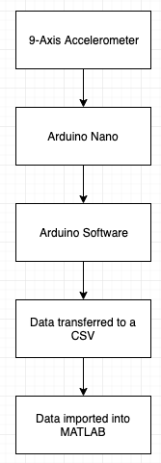

Figure 1 Project flow chart

# Milestones

The first major milestone is the selection of the hardware for usage for the project. With the project’s goal, a 9-axis accelerometer was necessary, however the type and particular device needed to be chosen specifically. Completion of this milestone was achieved when a device that could collect 100 9-axis measurements per second and save to a storage accessible by the user was selected and integrated into the work.

The second major milestone was to design the enclosure of the device in 3D model by using Autodesk Fusion 360 software, then, printing it in 3D by using 3D printer provided by our project advisor. Since the device system that has been chosen for the project does not have a case, then one must be developed for it. Completion of this milestone was achieved when a 3D model of a case has been created using Autodesk software, agreed upon by the group, and printed and tested to ensure it can properly contain and protect the device.

The final milestone was to develop a completed code that allows for the user to clearly and succinctly view the 9-axis data in such a way that allows for conclusive determination of variance within pace patterns. The code was focused on taking a completed data set and using calculations to show pace velocity, unsteadiness, and any falls that took place in the duration of the data recording period. Completion of this milestone was be achieved when a 10 second recording, at the requisite 100 data sets per second, was processed, and the user was able to receive a clear output that displayed pace velocity, unsteadiness, and falls across the full data set with respect to time.

# Progress Description

There were four microcontrollers to select from: the Nordic Thingy:52, the Hexiwear, the Dialog DA14585, and an Arduino. Initially, the Nordic Thingy:52 was chosen due to its capability of collecting ten data samples per second for each of the nine-axis measurements, a feature that the Hexiwear and the Dialog does not have. While the Arduino is capable of firing ten times per second, self-written code must be implemented to do so. In addition, the manufacturing company for the Nordic Thingy:52 also released the open source code for their mobile application on GitHub, for both iOS and Android, which already has some code for processing. However, since the Nordic Thingy:52 has a slow firing rate of data, the Arduino ultimately was chosen.

**Exterior Design**

Designing the enclosure of the project in 3D is one of the major concerns. We used Autodesk Fusion 360 to sketch the enclosure of the device before print it as a 3D model using 3D printer. There were many useful sources like videos on YouTube that described the major steps needed to create and design a 3D device by using Autodesk fusion 360. There are two major considers while make the design, scale and the material. scales here is the Dimension of the chips and the battery and leaving some space for the wires. The initial dimensions were taken from the datasheet of each component of the device. Download the 3D models of the device components from Autodesk library was a useful step and saved us time in design each component by itself before put it together. Also, it help to get an initial idea how the inside of the enclosure will look like. Because it is a wearable device, it must be small and lightweight. The material of the package mainly will be ABS plastic. The final dimensions of the enclosure were 60mmX50mmX28mm. Figure 2: eclipse was added to the device to make wearable. Figure 3: the final design of the enclosure.

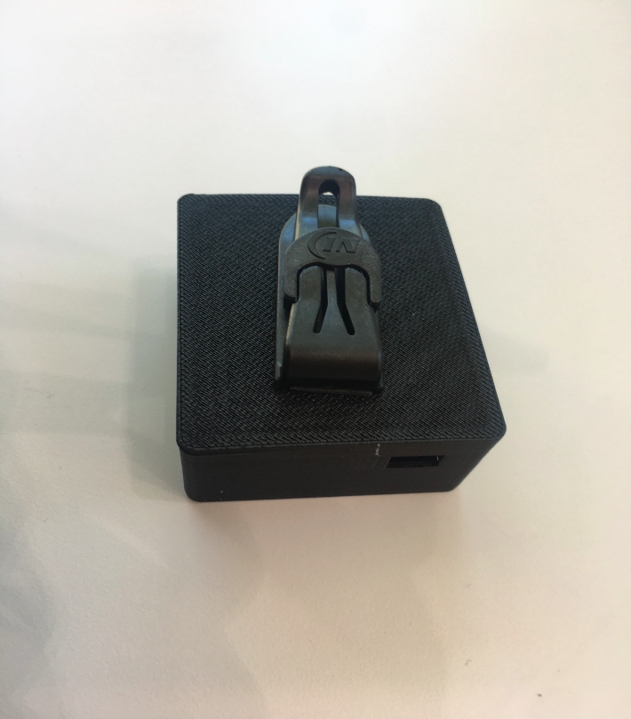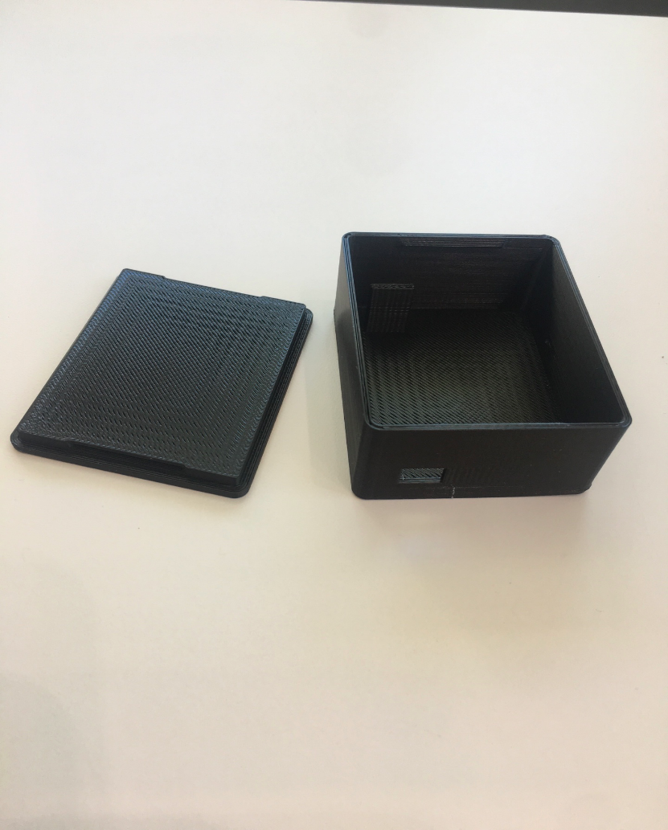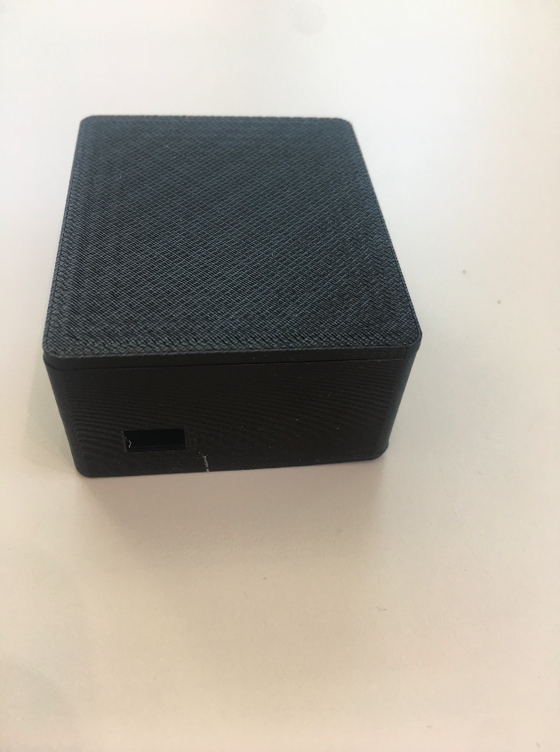

Figure 2 Device with eclipse

Figure 3 Full enclosure

**Arduino Initialization**

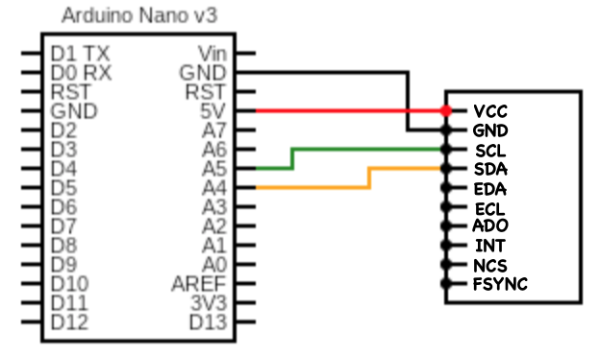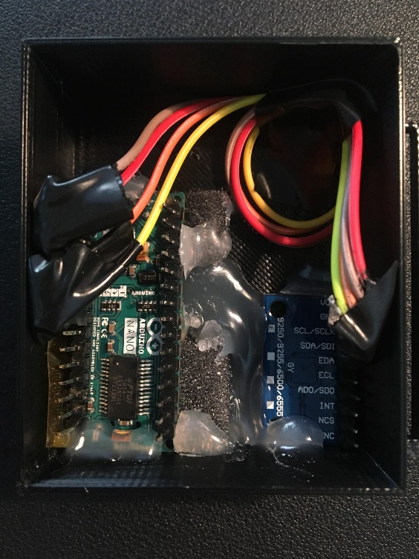The arduino nano was wired to the MPU 9250 and connected to the computer via a USB wired connection. Once the case design was completed and a prototype achieved, the arduino and accelerometer were packaged inside the case securely as shown below. Hot glue, electrical tape, and foam were all used to ensure a snug fit and prevent shorting. A wiring schematic is also shown.

Figure 4 Device schematic and final product

**Data Fusion**

Once the raw data was collected, converting the data into fusion measurements would be viable to observe changes across the data points all at once. To this end, the accelerometer and magnetometer data went into equations to determine the angle of roll, pitch, and yaw at a particular instant. These equations were used to plot the aforementioned angles to observe patterns in their outputs. The used equations are described below. Figure 1 shows a comparison of the raw data recorded by the device on the accelerometer and magnetometer and the roll pitch yaw data calculated. This data was used as simplified visual tools to identify trends in data.

|  |  |  |
| --- | --- | --- |
|  |  |  |
|  |  |  |
|  |  |  |

Figure 5 Raw accelerometer and magnetometer data and processed roll, pitch, and yaw data

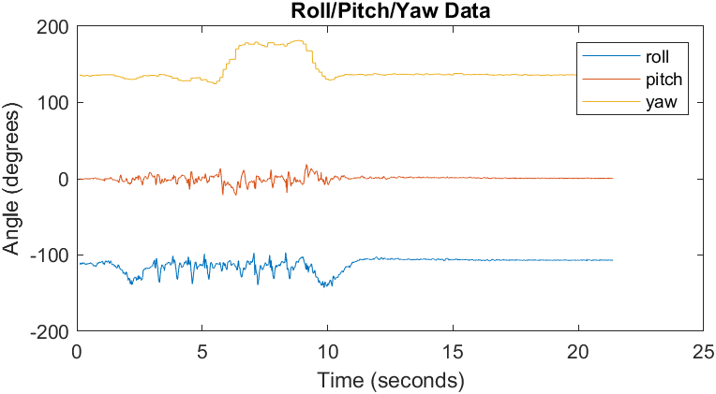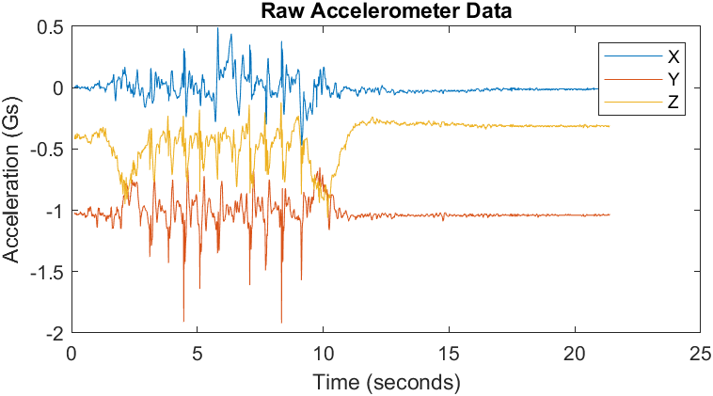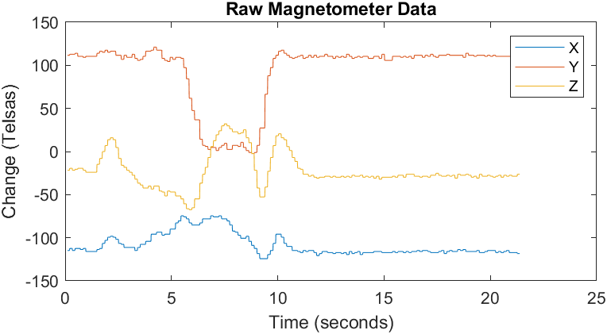

*Figure SEQ Figure \* ARABIC 1. Data recorded before and after being processed using component angles of motion.*

**Gait Speed**

The overall data stream was broken up into various parts so as to properly judge the actions therein. The first of these parts was the initial sitting phase. From the moment the device begins recording, the wearer is determined to be in this state. The transition to standing, in order to walk, is determined by a threshold set upon the gyroscopic data. Once the magnitude vector of the gyroscopic data exceeds 15 [rad/s], the wearer is then considered standing. The threshold value of 15 [rad/s] is arbitrary, but since the gyroscopic data begins at zero, and that the motion of rising to stand is the first noticeable bump in the gyroscopic data, the value has proven effective at determining the beginning of the standing motion.

The next important timestamp is the turn after walking the first three meters. Observing the data, the action of turning around was most visible in a string of data outputted by the Arduino labeled Horizontal Direction, as one of the calculations the device runs on the recorded data. In Figure 2 below, the action of beginning the turn can be seen when the horizontal direction begins its large drop at roughly the 6 second mark. The beginning of the turn is not the timestamp, however. The timestamp (later referred to as ) is considered to be the midpoint of the action of turning around. In order to split the total period of walking in half, the timestamp of the turning around midpoint was determined by taking the mean of the horizontal directional data and determining the point at which the data’s drop goes below the mean. Once the data has dropped past the mean, the data is considered to be reflective of the period of walking the second three meters. The third important timestamp is determined in the same manner, but through the inverse. Once the rise in the data has exceeded the horizontal directional mean, the data is considered to be recording the wearer turning to sit back down in the chair (with the timestamp later referred to as ).

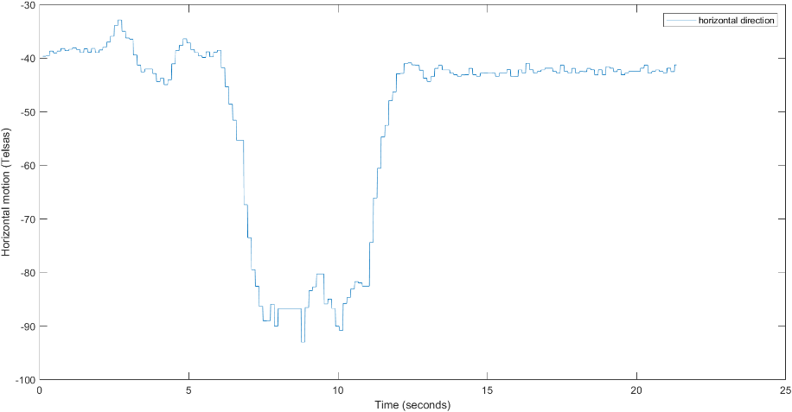

Figure 6 Horizontal directional data used for timestamp detection

*Figure SEQ Figure \* ARABIC 3. The horizontal direction data used to identify the action of turning around.*

The fourth and final important timestamp is the point at which the wearer is determined to be sitting down, which marks the conclusion of the test. Observations showed that the roll, pitch, and yaw data held constant once the wearer was seated and still, so the roll, pitch, and yaw data points at each time point were summed. The time point at which the difference in summed result between that data point and the one that came next was less than 0.01 was considered to be the first point where the wearer is fully sitting. The 0.01 difference threshold was determined so as to allow for very minute shifts in motion to still be considered the wearer’s stillness, while being so close that the data must be stabilizing.

Once all of these timestamps are calculated, valuations of the test can be made. The overall duration of the test is considered to be the time from 0 as the start until the timestamp denoting the patient is seated and still. The established norms for the timed up and go test determined by the CDC use the overall time of the test to make valuations of a patient’s health, which justifies the need to determine the testing time.

Using the testing time and the standardized measurements, moving velocity of the wearer can be determined. The wearer travels two preset and premeasured three-meter distances. The first three meters can be timed by using the timestamp of standing until the timestamp of turning. Taking the three-meter interval and dividing by this time value, an estimate of the patient’s walking speed for the first three meters can be calculated. The second three meters can be measured by using the timestamp of turning until the timestamp of turning to sit. Taking this three-meter interval and dividing by this second time value, an estimate of the patient’s walking speed for the second three meters can be calculated.

**Peak Analysis**

A criterion in determining gait stability is the uniformity in step time, for which the time between steps are consistent as the subject walks in one direction. To test step time consistency, the times points at which a step was taken must be tracked. For the th recorded time point, the magnitude of the acceleration vector retrieved from the accelerometer is computed, as shown in Eq. 1.

|  |  |  |
| --- | --- | --- |
|  |  |  |

When plotting the acceleration vector magnitude against time vector and comparing the plot to the recorded video of the subject’s gait, peaks with large amplitudes in the acceleration magnitude are found to be correlated to each step the subject is taking. As seen in Figure 3, while the subject is walking, an overall baseline in the signal is observed, with exceptions shown at instances where there are peaks with large amplitudes. Peaks were identified as step counts based on the following conditions: (1) a time window of 0.25 seconds between identified peaks to prevent identifying neighboring local maxima due to noise, and (2) a minimum peak height of 1.15 times the mean of the acceleration magnitude to prevent identifying local maxima at the baseline.

The steps are then categorized by the direction they are being taken in. The time values of the step-correlated peaks are cross-referenced with reference times and to determine whether a peak corresponds to a step in the forward direction or in the backward direction. If is less than , then the respective peak corresponds to a step in the forward direction. If is greater than but less than , than the respective peak is said to be a step in the backward direction. Categorizing by direction is done since the gait speed in the forward direction might not necessarily be the same in the opposite direction.

With the exception of the first step in the forward direction and the first step in the backward direction, the step times are computed in both directions, using Eq. 2 for the respective direction.

|  |  |  |
| --- | --- | --- |
|  |  |  |

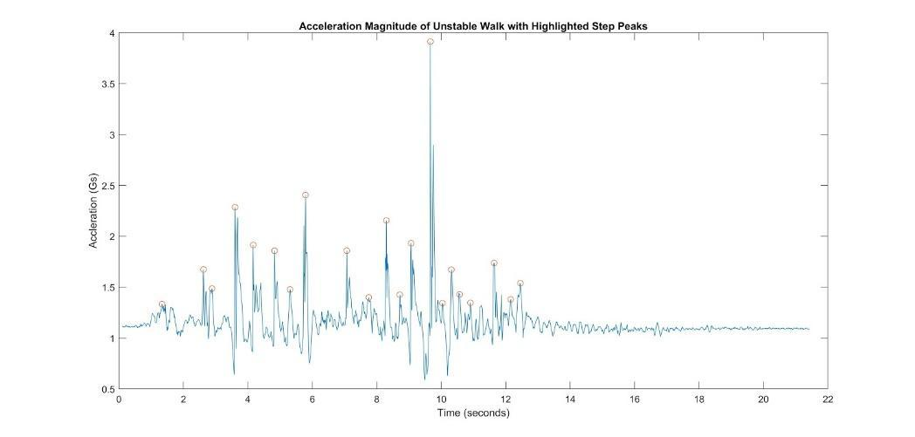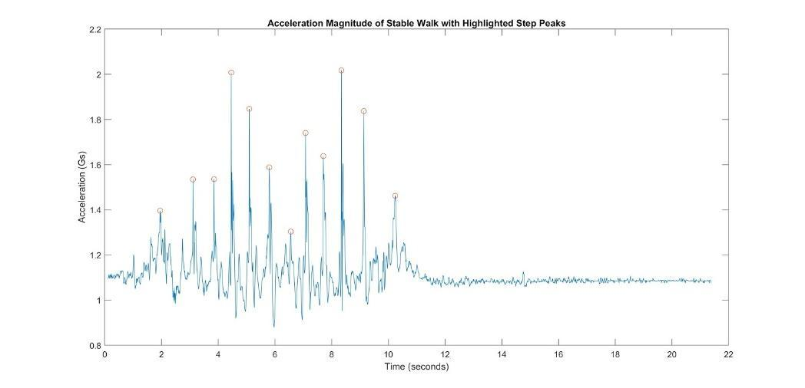

Figure 7 Magnitude of the acceleration vector for unstable (top) and stable (bottom) gait. Circled peaks represent steps

Step times are consistent if each step time do not deviate too much from one another. The mean of the forward step times and the mean of the backward step times are computed, with a deviation of 0.2 accepted such that a step time is considered to be consistent if for their respective directions. If falls out of range, then the step at is inconsistent and potentially unstable. A step time consistency ratio (STCR) is computed using Eq. 3, such that high STCR represents overall uniformity in step times, whereas low STCR represents nonuniformity in step times and is an indicator for unstable gait.

|  |  |  |
| --- | --- | --- |
|  |  |  |

To test the accuracy of detecting nonuniform step time, 23 samples were taken using the TUG test with the device, 12 of which were known to be normal walks, and 11 were known to be wobbly walks. Setting a minimum STCR of 65% in order to be detected as having normal (stable) gait in terms of consistent step times, 9 samples were correctly identified as normal, and 10 samples were correctly identified as wobbly. Sample testing of the device and processing showed that gait stability (or instability) of the wearer of the device can be detected in terms of the STCR with 82.61% accuracy.

**Gyro-X Stability**

In order to detect for left to right swaying in the test, gyroscopic data about the x-direction was analyzed. Due to the orientation of the device, it is the x-direction that would detection motion of the wearer shifting from side to side. Since the test is meant to be a completely straight path from chair to three-meter mark and back, this would mean that side to side data during the walking periods would be events of instability, as the wearer wobbles from side to side.

Detection was achieved via a threshold. Using the timestamps mentioned earlier, the data was broken into periods that were determined to solely contain the walking data. With these periods of data, there were two thresholds applied. The first was considered to be a simple event of instability, detected when the gyroscopic data in the x-direction exceeds . The mark was chosen to give an amount of leeway, considering that even the most stable walk will have a bit of sway in the wearer’s body, so only substantial deviance from the norm would be detected. The second threshold detected a higher level of instability. By increasing the threshold to , only more major deviations from the norm were detected. Events that triggered this threshold were considered major instances of instability.

Using the thresholds, data could be detected to be stable or unstable by measuring the instances of detected instability. Once all data points considered to be events of instability were recorded, the number of those points, divided by the total number of data points became the measure of instability. Using a threshold of 0.02 on both moderate instability and major instability, data sets where the wearer was known to be stable versus data sets where the wearer was known to be unstable were detected with 81.25% accuracy. In the instance where a test triggered both thresholds, that test would be considered to be an extremely unstable walk. Only two data sets tested met this mark, and both were tests where the wearer was intentionally walking unsteadily.

# Engineering Constraints

Since the device should ideally be portable and is capable of being clipped onto the waistline or a pocket, the manufacturing constraints include the size and weight of the device as well as the wireless communications. Since the device is wireless, it is instead battery-powered, thus a light battery as well as a light Arduino Nano module is considered so that the entire device does not apply too much weight on the waistline or shirt pocket. That is, the client should be able to comfortably use the device without hindrance due to the weight of the device.

In addition, because the device is wireless, using a Bluetooth module is considered as means of data transfer. While keeping the dimensions of the device compact, the device should still maintain its functionality. However, since the transmitter is placed within the device and the receiver is connected to a laptop, the device must be within a ten-foot radius from the laptop in order for data to transfer. Since the device is technically in the development phase and not for market, the ten-foot requirement is reasonable for research purposes.

# Engineering Standards

Currently, there are no standards set for Bluetooth, as the previous set standard IEEE.802.15.1 was withdrawn in 2018 [1]. The power supply is a portable 500-mAh 3.7-V lithium ion polymer battery. The Arduino Nano uses the ATmega328P as its microcontroller and operational under temperature conditions of -40 to 85 degrees Celsius.

# Scheduling

The first meeting was set on November 2018 to establish the project goals and thesis. The project goals and duties were based software, hardware, and the application for data reading in phone or computer. The main thesis at December 2018 meeting was to establish algorithms and codes that needed to process data into readable information. Then, each one of the group worked on different device to be used as base for the project. The Nordic Semiconductor Thingy 52 was tested and worked on. However, because of engineering constraints and standers the device changed to Arduino Wireless Bluetooth and Nano. Figure 4, represents the Gantt chart of our duties and meetings.

Corresponding to the tasks on the chart, Task 1 was to establish the thesis of the project and its goals. Task 2 was to schedule a rough timeline for the plan to achieve those goals. Task 3 was to search for potential devices to be used as the base for our project to record raw data. Task 4 was the testing of these potential devices for Task 5, the selection of the ideal device for the project. Task 6 was the downloading of the source code for the Nordic Semiconductor Thingy application and the modifications made to it. Task 7 was the integration of Firebase to the Thingy application in order to save data. Task 8 was the re-conferring over the selection of the device, and the selection of the Arduino to be the new base for the project. Task 9 is to develop a 3D model of the casing for the wearable portion of the device, and Task 10, currently ongoing, is the development of MATLAB algorithms to process the raw data the finished device can collect.

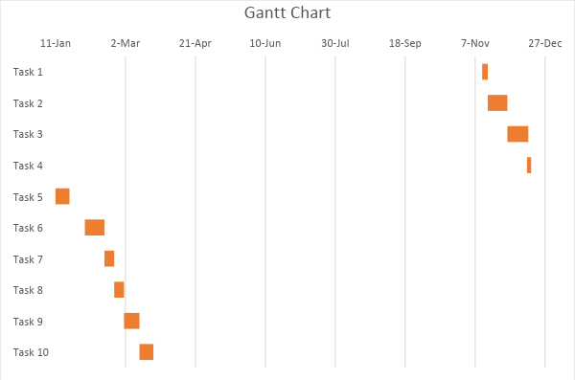

Figure 8 Gantt chart of the project schedule

# Budget

Table 1 Budget summary

|  |  |
| --- | --- |
| Items | Cost in US Dollar |
| Dialog Semiconductor SmartBond | $66.80 |
| MikroElektronika Hexiwear Wearable Development Kit | $77 |
| Each one of the group was applied with The Nordic Semiconductor Thingy 52 device | $40 for the device |
| ARDUINO Nano [A000005] | $21.78 |
| HC-05 Arduino Wireless Bluetooth Receiver RF Transceiver Module Serial Port Transmitter Module | $10.57 |
| ADAFRUIT INDUSTRIES 1578 Lithium Ion Polymer Battery - 3.7v 500mAh | $11.24 |
| Total | $ 227.40 |

# Conclusions

This has been a report on the progress towards developing a system to monitor human pace and steadiness with a custom designed wearable sensor and device specific code for processing the recorded data. The choosing and work towards the hardware portion of the project has taken the bulk of the time of the project. This is on account of the Nordic Semiconductor Thingy being selected as the base for the project, then after experiencing difficulty when working with Swift, the language in which its code is written, and with the device’s own innate limitations on its data acquisition, the Thingy was determined to not be a fruitful base for the project. This lead to a shift to an Arduino based system, which allowed for more ease and greater control over the coding aspects of the hardware and over the physical presentation of the device to be worn. With the hardware selection finalized, the project now focuses on modeling the casing for the wireless system and the code for processing the recorded data. The currently chosen plan for the casing of the system is a small 3D printed box with a clip, to be used to keep the device in place on the user. The development of the code for processing is the largest portion of the project remaining, of which there is much work still to be done. Once the code is finalized, then the project will be complete, and the desired final product: a cheap, wearable sensor to monitor a patient’s pace and unsteadiness, will be complete.

# Bibliography

1. Institute of Electrical and Electronics Engineers, “IEEE 802.15.1-2005 - IEEE Standard for Information technology-- Local and metropolitan area networks-- Specific requirements-- Part 15.1a: Wireless Medium Access Control (MAC) and Physical Layer (PHY) specifications for Wireless Personal Area Networks (WPAN),” *Institute of Electrical and Electronics Engineers*, 2005.
2. Tran, L. (2017). Data Fusion with 9 Degrees of Freedom Inertial Measurement Unit To Determine Object’s Orientation. *California Polytechnic State University, San Luis Obispo*.